Intro to financial accounting
- What is accounting
  - Recording, categorising summarising and communicating financial info about the organisation
  - Cycle of processing transaction data, aggregating data and announcing results in a report
  - Used to aid economic decision-making and communicate financial consequences of these decisions
  - Reality is a bottom-up approach – start with economic activity, use critical thinking to make accounting judgements, which provides useful info to aid decision
  - Not black and white – grey areas require judgements to be sorted into black and white
  - Regulation aims to curb these judgements from being opportunistic
  - Focused on financial accounting for the outside world. Audience is investors and creditors.
- Public financial reports. Why offer them?
  - Open ended questions interpreting financial statements, no essays or cases
  - Main elements of these reports are balance sheets, income statements and cashflow statements
  - Demand for financial info from key actors
  - Builds trust – social good / public policy. People make trust-based decisions using the financial viability of the economy, per accounting reports
- Key actors – owners, lenders, tax authorities, regulators, customers
  - Financial accountant hired by firm to prepare financial reports
  - Auditor – independent agent hired to assess the financial reporting quality of the firm (Big 4). Audited financial statements are not always fraud free
  - Forensic accountant – investigate fraud and financial irregularity
  - Standard setters – IASB develops international financial reporting standards (IFRS)
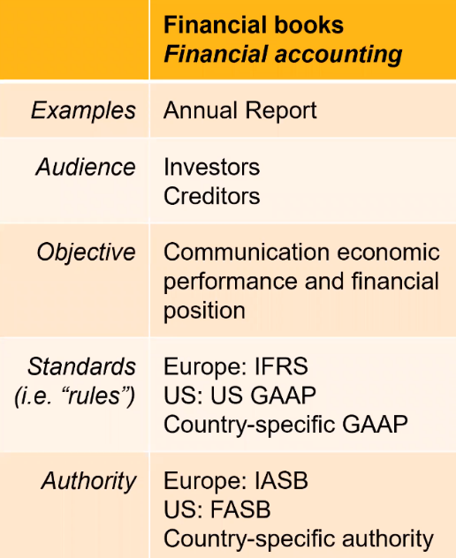
- Key info in public financial reports:
  - Fundamental financial performance over previous years
  - Information about the business environment
  - Assets – the value of what the company owns
    - Current – cash, accounts receivable, inventory
    - Non-current - property, equipment, goodwill, intangible assets
  - Liabilities – what you owe to others
    - Current – accounts payable, notes payable, maturities of long-term debt
    - Non-current – long-term debt minus current maturities

- Accounting equation is derived from assets and liabilities.
  - Owner’s equity = assets – liabilities.
  - Double entry is what allows this equation to always hold
  - Depreciation is tangible assets, amortisation is for intangible assets (brand, software)
    - Depreciation expense categorisation depends on the asset which is depreciating
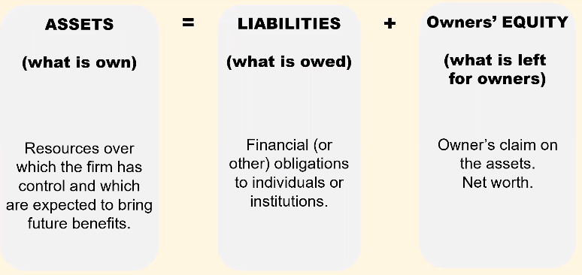

Answers to McDonald’s case
6. No
7. Data on page 36 (property and equipment) can show this. Depreciation usually associated with selling, general and admin expenses.
8. Franchise model – accounts receivable from the franchisee who owes them money for loans.
9. Fair value (market price) would increase for land and property. Historical prices more verifiable.
- Big tension between fair price and historical price as valuation method
- IFRS allow revaluation at fair value, American one does not
10. Investors more confident where reports are audited

Operating

Textbook reading
- Accounting – process of identifying measuring recording and communicating economic activities. Used internally (decision-making and externally (valuation).
- GAAP is based on IFRS, issued by the IASB. GAAP guided by qualitative characteristics:
  - Relevance
  - Faithful representation
  - Comparability
  - Verifiability
  - Timeliness
  - Understandability
  - Historical cost – each economic transaction based on original cost, e.g. land which has appreciated since being purchased
  - Recognition – revenues recorded when earned, which is not necessarily when cash is received.
- Financial statements: statement of income, balance sheet and statement of cash flows
  - Income summarises revenues less expenses over a period of time
  - Balance sheet shows assets, liabilities and equity at a point in time
    - Assets include cash, A/R, prepaid expenses, equipment
    - Liabilities include A/R and unearned revenue
    - Shareholder’s equity are the net assets owned by shareholders (assets minus liabilities)
  - SCF explains the sources (inflows) and uses (outflows) of cash over a period of time
  - Financial statements accompanied by notes at the end which provide greater detail about the amounts shown, or qualitative info
- Transaction analysis and double-entry accounting – the accounting equation shows that the total assets of a business must always equal the total claims by creditors and owners
  - Assets = liabilities + shareholders equity
  - Accounts see financial transactions as economic events which change components of the accounting equation. Triggered by info from source documents e.g. invoices
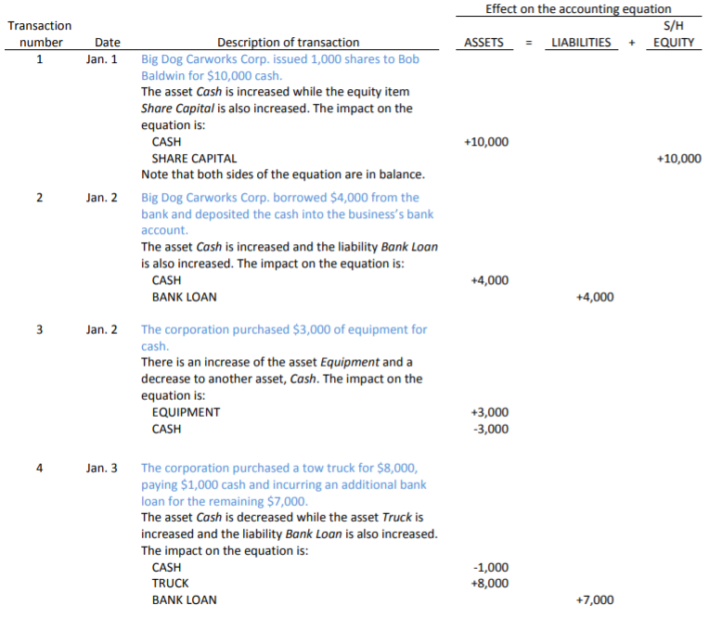

Financial Accounting fundamentals
- Introduction
  - The Flow (Csikszentmihalyi)
- 3 financial statements
  - Accounting equation: assets = liability + equity.
  - Balance sheet snapshots this accounting equation, static at a specific time.
    - Assets and liabilities classified by maturity – current is one operating cycle; non-current is over multiple operating cycles. Operating cycle is one year.
    - This helps us assess liquidity through working capital (CA – CL) and the current ratio (CA/CL).
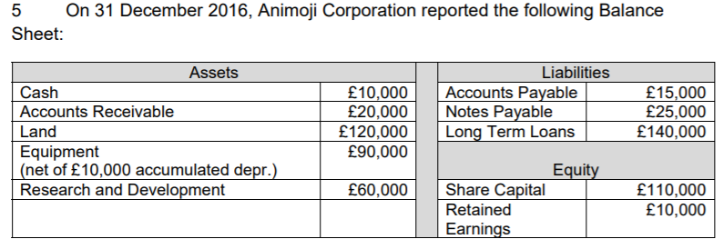
  - Income statement is a summary of inflows and outflows over a period, reporting profits through the equation: revenues – expenses = net income
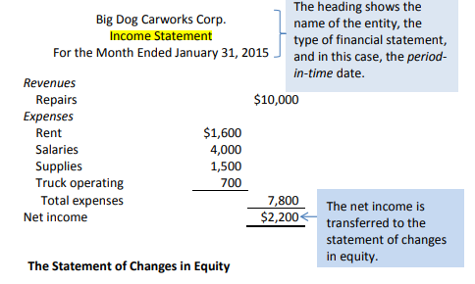
    - Showing components of income helps investors more accurately assess financial health e.g. operating income vs gain on equipment sale
    - Also known as:
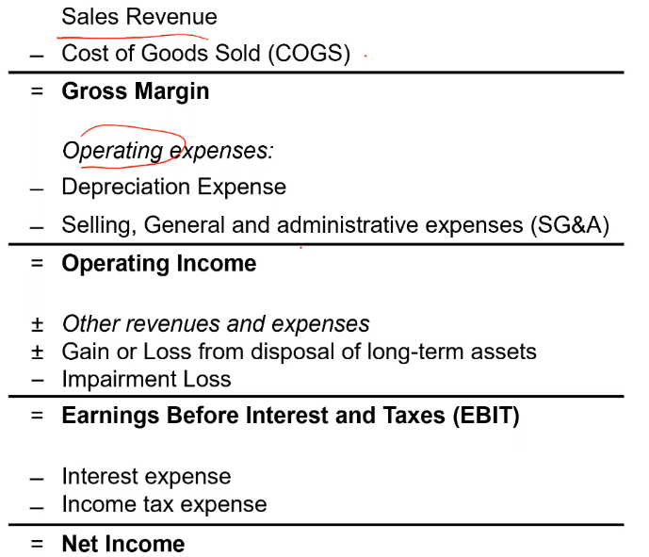
      - Revenue
      - Cost of sales
      - Gross profit
      - .
      - .
      - .
      - Operating profit
    - Revenue is not income.
    - Metrics to assess profitability: gross profit ratio, operating profit ratio, return on assets (net income/assets)
Linking the income statement and balance sheet together
  - Net income goes into retained earnings, which is owner’s equity

Aggregation exercise
- Recording transactions – double-entry, T-accounts, debit and credit
  - Purchasing car with bank loan – assets increase, and liabilities increase
  - Using cash to pay sister – cash assets decrease, owners’ equity decreases as expenses increase, thus net income and retained earnings decrease
- Building up financial statements

Recording transactions
T-accounts
- Double-entry system; decreasing one item must have an equal and offsetting increase in another item
  - Buying a £15,000 car using our cash account of £20,000
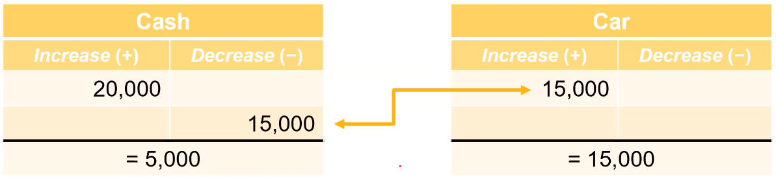
  - Paying £8 to our sister from our £15 cash account
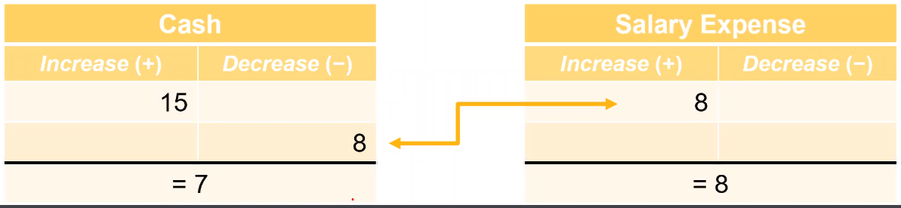
- For assets, use debit (increase) and credit (decrease) and place the sum amount on the side of the greater value:
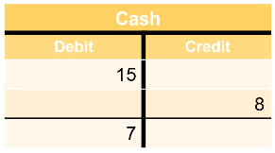
  - Account has a debit balance because the sum is under the debit side.
- Applying T-accounts to the accounting equation:
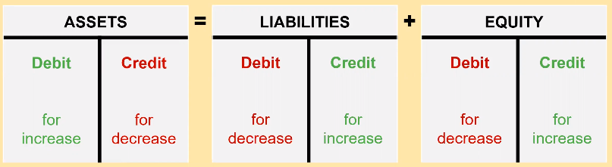
- Net income (income statement) tied to retained earnings (equity).
  - Increased expenses decrease net income, decreasing retained earnings and equity.
  - Increased revenue increases net income and retains earnings, therefore equity.
- Income statement displays revenue and expenses for a period of time. Increase in assets is a debit.

Building up the financial statements
- Record sale the sale in T-accounts and journal – increase in cash and
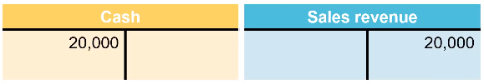
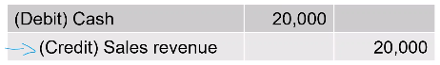
- Record the cost of the sale – decrease in inventory, increase in expense and decrease in retained earnings and equity
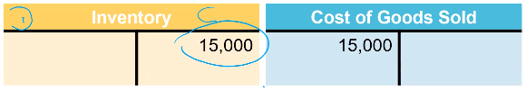

Examples – transactions in financial statements
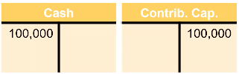
- Receiving £100,000 cash from owner-investors
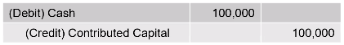
- Buying a second-hand car for £15,000 cash
  - Credit cash, debit inventory
- Selling car for £20,000 cash
  - Debit cash and credit sales revenue for £20,000.
  - Debit cost of goods sold and credit inventory for £15,000
  - Net income is £5,000

Generating the balance sheet
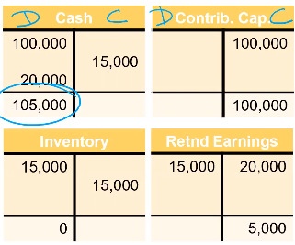

Cash v accrual accounting
- Accrual accounting is the process of recognising revenues when earned and expenses when incurred, regardless of when cash is exchanged.
  - Accrual accounting recognises revenues when goods are provided instead of when the cash is received
  - Accrual accounting recognises expenses when assets are consumed or liabilities incurred, instead of when cash is paid
  - Expenses and revenues regarding a sale are recognised simultaneously, the ‘matching principle’. This allows us to measure profitability of economic activities during an accounting period, which is why most companies use it.
- To satisfy the matching principle and have revenues and expenses reported in the same period, we have 5 types of adjusting entries:
  - Prepaid assets – amounts paid in cash and recorded as assets until used
    - You prepay (asset) so that you get a future benefit (becomes an expense). Prepaid expensed is expensed as the benefit is consumed
    - Examples include insurance, rent, advertising
  - Unearned liabilities – revenues received in advance from customers are recorded as liabilities until the goods are delivered
    - Receive cash (asset) because you have to perform a future service (becomes a liability).
    - Cash debited, liability credited. Then when service performed, liability decreases and equity increases (as revenue recorded)
  - Property, plant and equipment assets
    - Depreciation allocates the costs of these over the duration of the period of time its expected to be used, instead of a lump sum.
    - Purchasing equipment: credit cash and debit equipment. Depreciation: decrease equity and decrease value of equipment (credit assets)
  - Accrued revenues – amounts not yet received for which goods have been provided
    - Revenues earned but not collected.
    - Example: rents receivable is an asset debit, credit of rent earning is an increase in revenue thus equity. When rent is paid, rent receivable turns into cash (debiting), rent receivable is credited
  - Accrued expenses – amounts not yet paid for goods already received
    - Expenses accrued but not yet paid, even though we have consumed it
    - Increase in salaries payable for example, a liability increasing (credit).

Conclusion

Chapter 2 – The Accounting Process
- Accounts accumulate info recording changes in an asset, liability or shareholder’s equity item. Maintained in a general ledger
  - Asset accounts: cash, A/R, unused supplies, prepaid expenses, buildings, land, inventory
  - Liability accounts: A/R, wages payable, bank loans, unearned revenues
  - Shareholder’s equity accounts: share capital, retained earnings, dividends, revenues and expenses
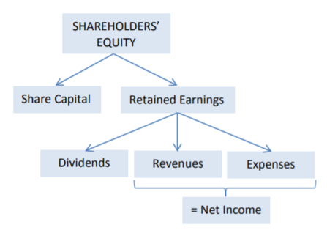
    - Retained earnings is the sum of all net incomes over the corporation’s life, less any dividends distributed to shareholders
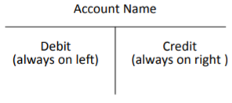

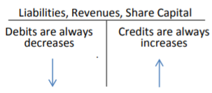

- T-account is a simplified account which shows increases and decreases in an account.
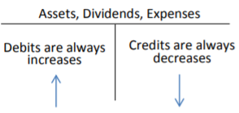
  - Revenue and share capital transaction increase shareholder’s equity so they are recorded as credits
  - Expense and dividend transaction decrease shareholder’s equity so they are debits

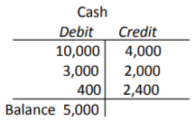
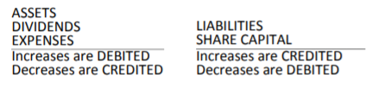
  - Account balance determined by adding and subtracting increases and decreases in an account:
- Transaction analysis using accounts – double-entry accounting means every transaction is recorded in at least two accounts, where the total debit equals the total credits.

Example
- Issued 1,000 shares for cash
  - Cash is an asset account, so an increase means a debit
  - Share capital is a shareholder’s equity account, so an increase means a credit
- Equipment purchased for cash
  - Cash credit
  - Cash debit
- Truck bought for £8k. £1k cash and £7k bank loan
  - Debit equipment 8k
  - Credit cash 1k
  - Credit liabilities 7k
- 2.4k for prepaid insurance
  - Asset debited (increased)
  - Asset credited

Using formal accounting records
- So far, we’ve used T accounts. General journal is a document chronologically recording a business’ debt and credit transactions (called book of original entry)
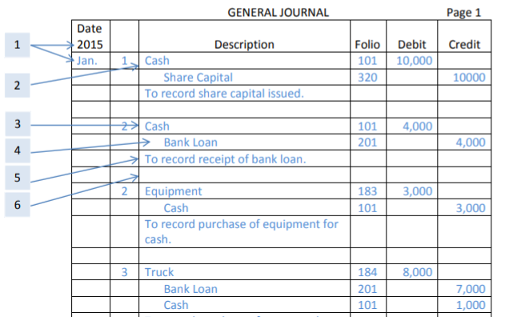
- General ledger contains all of a business’ accounts. Called the book of final entry

  - Accounts to be debited usually recorded before accounts to be credited
  - Folio is the number given to the account in the general ledger
  - Name of the account to be credited is on the second line and is indented
  - Explanation of the transaction is on the third line and is not indented

- The general ledger account is a formal variation of the T-account

Chapter 3 – Financial accounting and adjusting entries
- Adjusting entries to satisfy the matching principle. Means revenues and expenses recorded in correct accounting period.
- Operating cycle: cash on hand, expenses incurred (A/P), expenses paid, repair services performed (A/R), cash collected, cash on hand
  - Accounting period is comprised of several operating cycles
  - If an operating cycle is incomplete at the end of the accounting period, we need to consider how to account for this
  - Revenue recognition when earned, not when received.
    - First, when revenue is earned on credit we increase accounts receivable and decrease
    - When cash is received, decrease AR and increase cash
    - This second entry has no effect on revenue
  - Expense recognition – recorded as assets when costs are incurred to produce revenue in future accounting periods e.g. prepaid rent. Recorded as expenses when costs are incurred to earn revenue in the present e.g. rent expense.
    - Increase expense and increase A/R if expense incurred before cash paid
    - Then when paid, credit accounts payable and debit cash
    - If at the same time, credit expense and debit cash

Adjusting entries
- Review for potential adjustments done using the unadjusted trial balance.
- Adjusting prepaid assets
  - Asset account requiring adjustment is a mixed account because it includes balance sheet portion and income statement portion.
  - Prepaid asset of insurance, but by now one month of the policy has been used up
    - Policy was $2400, so one month worth $200
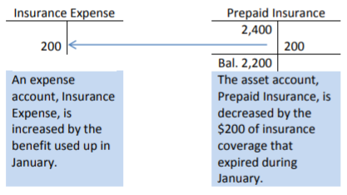
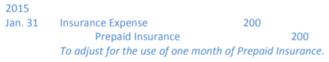
    - Transfer $200 from prepaid insurance to insurance expense
- Adjusting unearned liabilities
  - Received a $400 cash payment in advance of performing services, originally recorded as unearned repair revenue. Now, $300 of the $400 has been earned
  - So we debit unearned revenue by $300 and credit repair revenue by the same
- Adjusting plant and equipment costs are spread over the assets “useful life” because it will provide benefits beyond the year of purchase
  - Process of allocating this cost over the time period is called depreciation
  - Debit depreciation expense and credit accumulated depreciation account (a contra account)
- Adjusting accrued revenues (earned but not collected)
- Adjusting accrued expenses (incurred but not paid)

Supervision 1
Revision quizzes from lecture 1&2, assigned exercises
- 4 financial statements in the annual report – income statement, balance sheet, statement of shareholders equity, statement of cash flow. Accounting equation is that assets equal liabilities and owners’ equity. Adjusting entries ensure economic profit in each period can be measured (prepaid assets, unearned liabilities, accrued revenues and expenses, property etc.).
- Income statement communicates inflow of assets (revenues) and consumption of assets (expenses) over a period. This creates net profit, reported on the income statement and in the shareholders’ equity section of the balance sheet. The purpose of the balance sheet to communicate assets, liabilities, and the difference between the two at one point in time.
- Revenue = increase in assets or decrease in liabilities in return for goods sold. Expense = asset being used up, or obligations incurred when selling goods.
  - Net income is the difference between revenues and expenses
- Accounting equation: economic resources = creditors claims to these resources + owners claims to these resources

Grey areas / accounting judgements
- Retained earnings can be debit or credit.

Revenue recognition
- Accrual accounting – revenue only recognised when earned i.e. when a product has been delivered and the customer has accepted it.
  - Work must be completed, and the amounts must be realised
  - When you purchase concert tickets, it’s registered as a liability (deferred revenue/unearned revenue) until the concert is performed, then the revenue is recognised on the income statement.
    - Debit asset (crash) and credit deferred revenue before the concert
    - Then debit the deferred revenue and credit the revenue, increasing equity
  - If a company expects sales returns, an estimate of returns is reflected as unearned revenue.
- Record the sale (T-accounts and journals), then record the cost of the sale i.e. increase cash and revenue, then decrease inventory and increase affiliated expense (COGS).
  - Sales return in financial statement:
    - Debit the total cash, 90% as sales revenue credit and 10% as deferred revenue credit – portion of the revenue is deferred, liability.
    - Debit 90% of COGS, debit 10% of ‘return inventory asset’ and credit 100% of inventory

Fraud
- This creates the potential for fraud:
  - Overestimate returns so net income is lower and thus taxes are lower
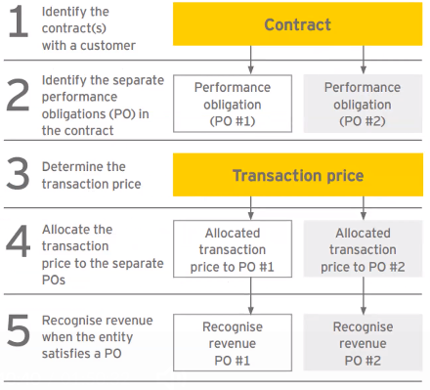
  - Underestimate returns to increase net income thus EPS, signalling financial health to investors.
  - Record revenue earlier to temporarily boost revenue
- IFRS 15 standard shows when to recognise revenue
  - This standard is trying to avoid fraud by booking revenues too early. This boosts net income, lets company pay money to the shareholders and leaves us
- Bundled products e.g. iPhones with software updates are owed to us
  - Phone delivered but service (updates) undelivered i.e. deferred revenue (liability).
  - Debit cash, credit sales revenue and credit deferred revenue
  - How do we come up with sold separately price for the product v service? Use observable prices or we can estimate it using expected cost + margin, for example

Farmville case
When to recognise revenues?
- All now: 'Zynga shall have no liability’ implies they assume they have earned the revenue as soon as your purchase it – we wont have an unearned revenue it will be earned.
  - Some revenue deferred – refunds possible and sometimes will happen
- ‘Revenue from sales of durable virtual goods recognised rateable over the estimated average playing period of paying players for the applicable game’
  - Not recognising when they receive cash, but when the service is provided and the customer accepts it. Sale of virtual tractor treated as a service.
  - Zynga not recognising revenue too early, it is postponing recognition.
  - What is the motivation for this? Delaying revenue recognition smooths the ‘fad revenue’ from people buying tractors lots and then stopping as people get bored. This policy smooths revenue, increasing it in the mid-to-long term.
- Why aren’t we worried about late recognition and tax fraud? Incentives are must stronger to recognise early as stock price will rise, earnings are linked to tax. Easier to fraud tax in other ways than fraud earnings.

Accounts receivable
- In a cash sale, the record of the sale is debit cash, credit sales revenue and the cost of the sale is debit COGS, credit inventory. But this is a cash transaction, In B2B situations companies may offer credit
- Accounts receivable is how we record executed sales, that haven’t been collected in cash yet
  - Here, record of sale is debit accounts receivable, credit sales revenue and the cost of sale is debit COGS, credit inventory.
  - Later, as we are paid, we debit cash and credit accounts receivable
- T-accounts shows an account beginning balance, debit and credit transactions, and end balance.
  - Debits on the left, credits on the right
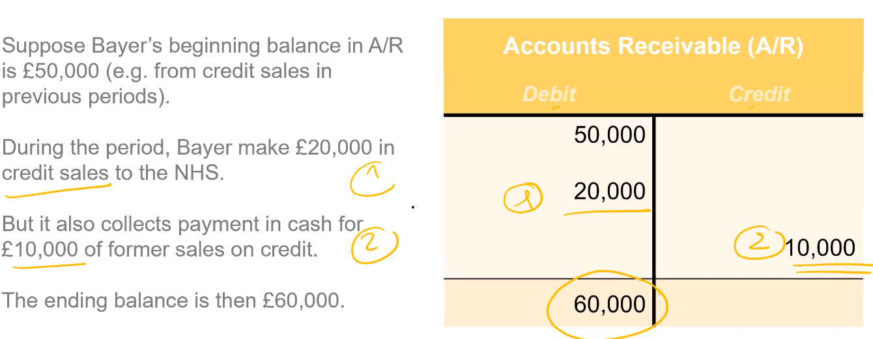

Allowance for doubtful accounts – AFDA
Contra-account of A/R – shows what proportion of A/R won’t be collected
Step 1. Record bad debt expense by debiting bad debt expense and credit AFDA. This affects income
Step. 2 When it actually defaults, do a write-off – debit AFDA and credit A/R. Doesn’t affect income
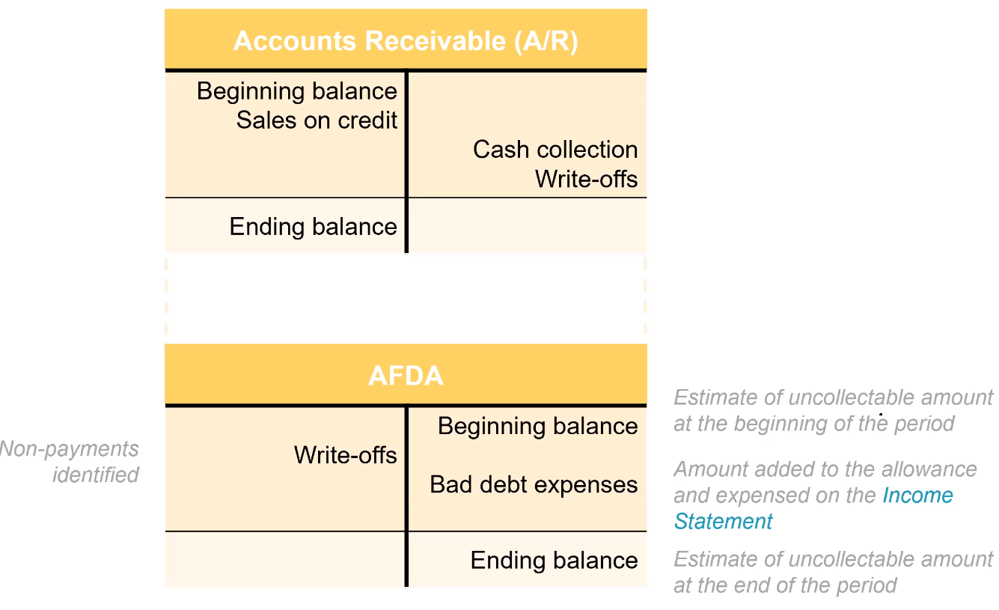
- If A/R is £5,000 and AFDA is £1,000, we need to put on 3 figures – gross A/R, uncollectable and net A/R.
  - Net is in the balance sheet, then gross and uncollectable amounts are in the footnotes
- Stops us overstating A/R by showing only gross A/R – accrual accounting, not cash accounting. Showing only net A/R could be distortive - % of clients which are defaulting is important to be able to see.
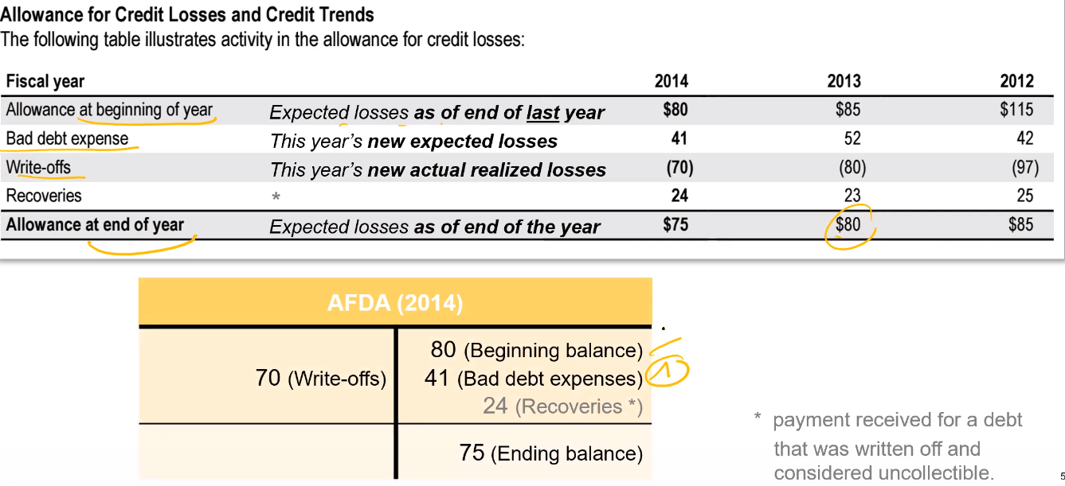
How can we artificially inflate income (to boost EPS) by varying the method used to account for accounts receivable and bad debt?
- Review hypothesis for the aging schedule – understate bad debt expenses and back the estimates using unrealistic historical patterns
- Act in period t-1 by taking a big bath – make poor results look worse in order to make future results appear better. Big loss is better than several small losses to investors.

Textbook reading
- Operating cycle: inventory purchased, liability incurred, cash payment to supplier is made, sale is made, account receivable results, cash collected from customer.
  - In the revenue portion the sale on credit is completed with the collection of cash
  - Not all receivables are collected – this is the focus of this topic
- Extending credit to customers can increase sales – however we should permit sales on account only to credit-worthy customers, to reduce the risk the accounts receivable will not be collected. This is known as bad debt.
  - Bad debt expenses should be matched to the credit sale of the same period, i.e. the expense should be when the credit sale was made, not when we realised the receivable would never be collected.

Estimating uncollectible accounts receivable
- Estimate the portion of sales that will not be collected in cash. This is done by creating a contra current asset account called Allowance for Doubtful Accounts (AFDA), which records estimated uncollectible receivables.
  - Contra to accounts receivable
- Uncollectible accounts are estimated via Bad Debt Expense on the income statement or the desired balance in allowance for doubtful accounts:
  - Income statement method estimates bad debt based on credit sales. Apply an estimated percentage loss to credit sales for the period, based on actual losses experience in past years.
  - Balance sheet method estimates uncollectible amounts via the aging of accounts receivables. Analyse accounts receivable according to relationship whereby the longer a receivable has been outstanding, the less chance there is of collecting it.
    - Bad debt expense: difference between the opening AFDA balance and the estimated uncollectible receivables at the year end
    - Alternative: simplified balance sheet method estimates uncollectible amounts as a percentage of the outstanding accounts receivable balance
  - Neither method is accurate in exceptional times e.g. Covid, financial downturns
- These estimates of uncollectible amounts (amount estimated in AFDA) are usually incorrect.
  - Credit balance in the allowance account if fewer bad debts than estimated occur, debit balance if the opposite.
  - Each time, estimates will be adjusted going forward to try and be more accurate

Writing off accounts receivable
- These estimates do not tell us which specific receivables will become uncollectable. When we know this information, we remove the amount of the specific account from the accounts receivable account. This is a write-off.
- The write-off reduces accounts receivable and the balance for doubtful accounts. The write-off therefore does not affect net realizable accounts receivable:
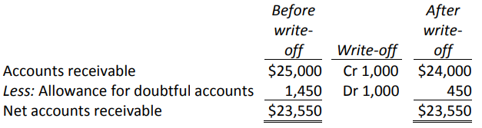
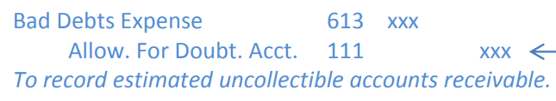
- A write-off does not affect bad debt expense; the adjusting entry to estimate uncollectible amounts was:
  - Needed as GAAP require bad debt expense to be matched to the period in which the sales occurred

Recovery of a write-off
- After writing-off an account receivable, we then become aware some or all of the amount will in fact be paid. This requires two journal entries:
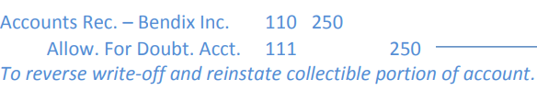
  - First entry reinstates the amount expected to be collected:

  - Second entry records the collection of the reinstated amount i.e. collectible portion of an account previously written off

Statement of cashflow
- Balance sheet (static snapshot of wealth) and income statement (profitability over a period) are insufficient to assess financial health. Without cash, a company cannot operate and will go bankrupt.
  - Accrual basis of accounting means the income statement doesn’t tell us how much cash we actually receive
    - E.g. depreciation is an expense, but not a cashflow
    - Credit sales shown as revenue, but no cash is received
  - Purpose of cashflow is to explain the difference in cash between two consecutive income statements
Cash flows come in or out because of fundamental business operations (operating), investment choices by the CFO (investment) and financial decisions (finance).

Technique and structure of cash flow
- Cash flow from operating activities – identified by items in the income statement and changes in the balance sheet items. Includes cash flows related to:
  - Running the core business in the short term
  - Changes in accounts payable and receivable
  - Changes in inventory
  - Two methods: direct method reports the cash effects of each operating activity. Indirect method starts with net income, undoes effect of all non-cash operations to calculate the net cash provided by operating activities.
- Cash flows form investing is changes due to investments in long-term assets
  - Purchasing and selling long-term productive assets
  - Purchasing and selling investment securities (stocks and bonds)
  - Lending money decreases cash, interest received when lending money is an operating cash inflow
- Financing activities: long-term liabilities and shareholder’s equity
  - Obtaining a long-term debt as a borrower increases cash
  - Paying off principle on a long-term debt decreases cash
  - Repurchasing equity decreases cash (increases EPS)
  - Paying dividends decreases cash

Indirect method to calculating operating cash flows
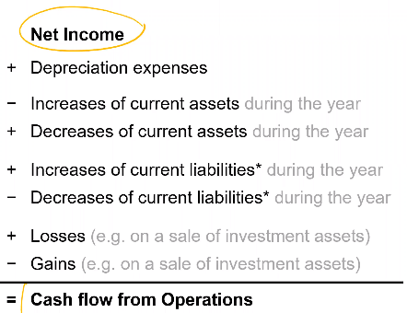
- Start from net income number
  - Correct for non-cash items
  - Correct for changes in current assets and liabilities

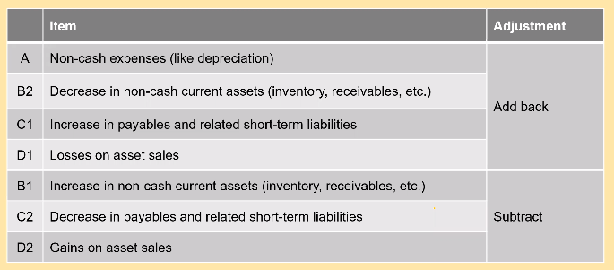
- Depreciation decreases income but no cash flow, hence we add it back to retrieve the cash flow from operations
- Adding back decreases in non-cash assets for the same reason. When we receive due cash we decrease our non-cash assets (accounts receivable). Decreasing A/R means we are receiving cash, so we add back this decrease to retrieve the net cash
- Add back increases in payables – not yet paid out the cash for the expense

Textbook reading
- Cashflow important as liquidity needed to pay bills. Statement of cashflows one of four key statements, provides summary of where cash came from and how it was used during the accounting period.
  - Describes the operating, financing, and investing activities on a company’s cash resources
- SCF useful for decisioning making on new purchasing, paying long-term debts and declaring dividends. Limited in use for assessing future cashflows as it is based on historical data.
  - Cash is anything the bank will accept for deposit
    - Cash equivalent – safe and easily recoverable investment (maturity of less than 3 months)
  - Possible to have negative cash i.e. overdrafts
SCF divided into three areas:
- Cash flow from operations i.e. principle activities producing revenue e.g. selling products and expenses on the income statement.
- Cash flow from investing activities involve increases and decreases in long term asset accounts – outlays for property, plant and equipment and cash proceeds from their disposal
- Cash flow from financing activities occur when there are changes to debt or shareholder’s equity accounts, i.e. long-term debts being re-paid or shares and dividends issued.

Analysis of cash flows
- Set up a cash flow table
- Calculate the changes in each balance sheet account
- Analyse changes in non-cash balance sheet accounts
- Prepare the cash flow from operating activities
- Prepare a statement of cash flows

- Calculating cash flow from operating activities;

Definitions, concepts and calculations
- Shareholder equity = Assets – liabilities
- Retained earnings is the sum of all net incomes earned by a corporation over its life, less any distributions of these net incomes to shareholders.
  - Adding net income to the previous term’s retained earnings and subtracting any net dividends paid to shareholders
- Assessing a company’s overall financial health
  - Look at its operations cash flow

